Incident Type: | 2012 | 2013 | 2014 | 2015 | 2015/2016
Fire/Rescue Calls | 191 | 216 | 250 | 293 | 220/225
1st Respond/EMS | 731 | 831 | 977 | 1034 | 803/771
TOTAL CALLS | 922 | 1047 | 1227 | 1327 | 1023/996
Metro Fire/Rescue | 44 | 50 | 53 | 71 | 49/52

Fire Inspection Activities to date
Total Inspections |  | Violations Found | Violations Corrected
Fire Protection  Pre-Occupancy  Fire Drills | 996  57  2 | 1304 | 967
Fire/ Rescue Calls only
Fire (40) 18%
Rescue & EMS (18) 8%
Hazardous Cond. (34) 15%
False Alarms (74) 33%
Good Intent (43) 19%
Service Call (14) 6%
Other (2) <1%

Explanations of these statistics are located on the Incident Type Report

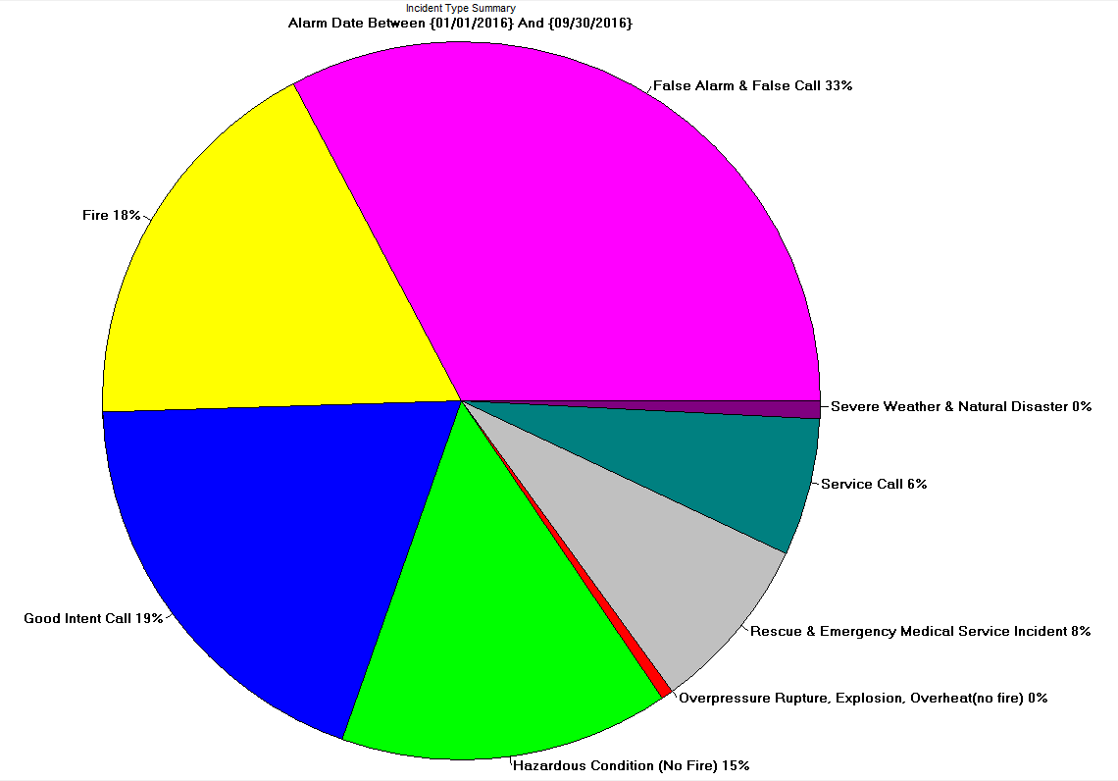
- 1053 total fire inspections have been completed to date. The majority of these inspections have been completed by paid-on-call staff.

