Incident Type: | 2012 | 2013 | 2014 | 2015 | 2015/2016
Fire/Rescue Calls | 191 | 216 | 250 | 293 | 200/200
1st Respond/EMS | 731 | 831 | 977 | 1034 | 710/687
TOTAL CALLS | 922 | 1047 | 1227 | 1327 | 910/887
Metro Fire/Rescue | 44 | 50 | 53 | 71 | 45/47

Fire Inspection Activities to date
Total Inspections |  | Violations Found | Violations Corrected
Fire Protection  Pre-Occupancy  Fire Drills | 849  44  2 | 1195 | 888
Fire/ Rescue Calls only
Fire (34) 17%
Rescue & EMS (14) 7%
Hazardous Cond. (29) 15%
False Alarms (66) 33%
Good Intent (42) 21%
Service Call (13) 7%
Other (2) <1%

Explanations of these statistics are located on the Incident Type Report

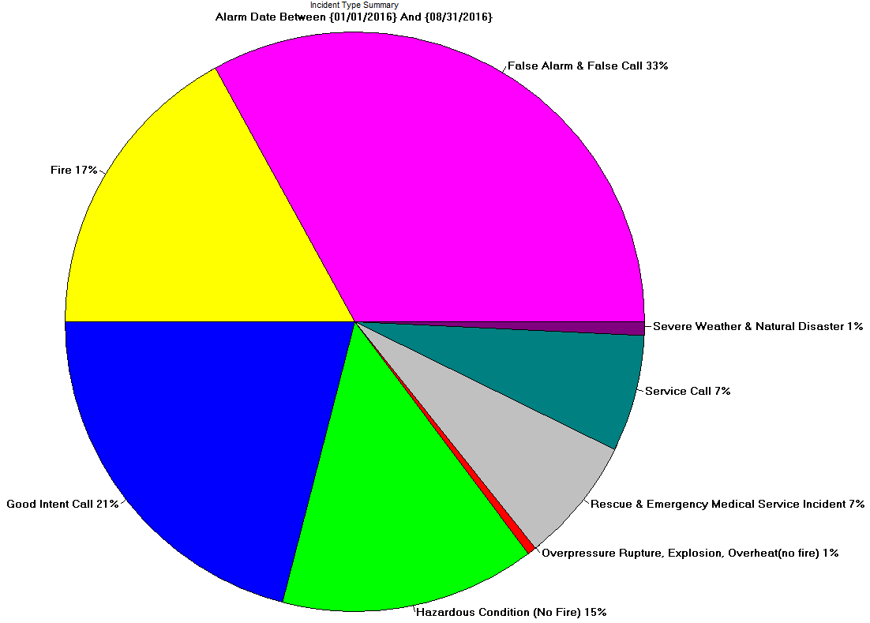
- 307 outstanding violations that have not been addressed. Business owners have 30 days to comply

