Incident Type: | 2012 | 2013 | 2014 | 2015 | 2015/2016
Fire/Rescue Calls | 191 | 216 | 250 | 293 | 174/173
1st Respond/EMS | 731 | 831 | 977 | 1034 | 615/583
TOTAL CALLS | 922 | 1047 | 1227 | 1327 | 789/756
Metro Fire/Rescue | 44 | 50 | 53 | 71 | 40/41

Fire Inspection Activities to date
Total Inspections |  | Violations Found | Violations Corrected
Fire Protection  Pre-Occupancy  Fire Drills | 731  37  2 | 1086 | 869
Fire/ Rescue Calls only
Fire (31) 18%
Rescue & EMS (13) 8%
Hazardous Cond. (25) 14%
False Alarms (54) 31%
Good Intent (38) 22%
Service Call (10) 6%
Other (2) <1%

Explanations of these statistics are located on the Incident Type Report

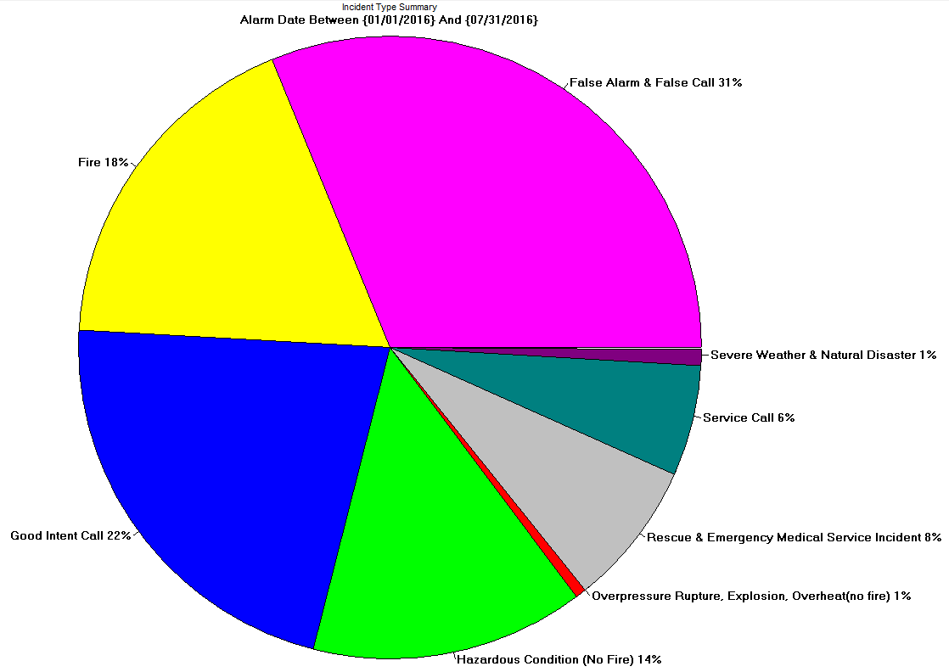
- Exit lights violations accounted for 283 of the total violations found

